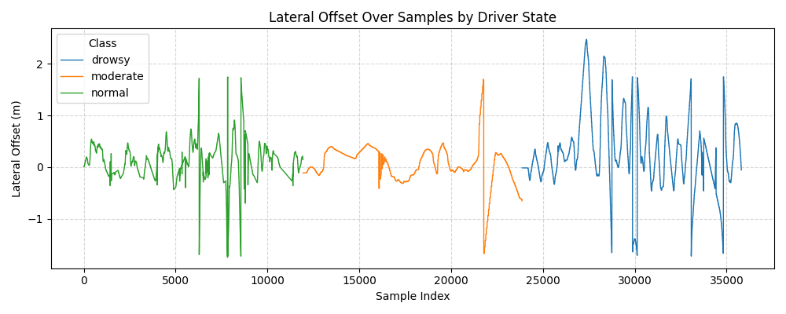

Fig.1 Data analysis on data capture(lateral_offset) by me on my laptop

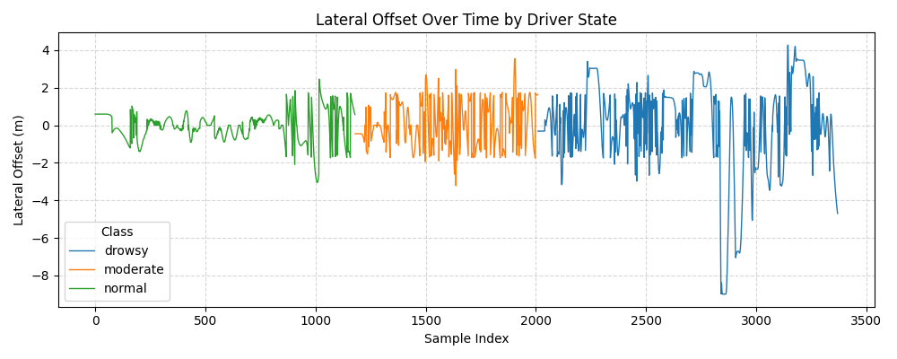

Fig.2 Data analysis on data capture(lateral_offset) by Mehdi.

This is for features related to the lane, which are SDLP(Standard Deviation Lateral Position), Lane Keeping Ratio and Lane Departure Frequency. Reasons:-
- Disambiguating “Off-Centre” vs “Off-Lane”: Lateral Offset measures the continuous distance from the lane centerline, but by itself cannot determine whether the vehicle is still in a driving lane or has crossed into a shoulder or sidewalk. Lane ID (−1 for off driving lanes) provides a discrete in-vs-out flag, so departure events are registered only when the vehicle truly leaves the lane. As seen in Mehdi’s data for a drowsy person, it went till -8.45 m, which should not happen at all. And for situations like this, if we had the lane ID, we would have debugged the error very easily or found the reason why it went like that.
- Accurate Lane Departure Frequency: Counting every instance where |offset| exceeds a threshold overestimates departures on wide lanes or curves, where a vehicle might legitimately approach the edge. Requiring a flip of lane_id from ≠ −1 to −1 ensures only genuine departures are counted in the case of 2 lanes in a particular direction, which we insisted on should be there when recording the data.
- Meaningful Lane Keeping Ratio: Lane Keeping Ratio = (samples in a valid lane) ÷ (total samples). Without lane_id, inference from offset magnitude alone can vary. Lane ID ensures robust in-lane detection across different maps and we can be sure that the vehicle, when in a drowsy state, has not crossed the other side of the road, and if it as crossed the other side of the road, then we can justify it.
- SDLP Focused on In-Lane Control: Standard Deviation of Lateral Position (SDLP) quantifies driver sway within the lane. Filtering out lane_id == −1 samples prevents SDLP from being inflated by large excursions during departure recovery, and is also easily calculated.
- Generalizability Across Roads: Roads vary in lane number. A pure-offset threshold tuned for one map can misclassify on another. Combining offset and lane_id adapts automatically to any map’s lane definitions.
- Lane Keeping ratio:-The fraction of samples where you remain in a valid lane (ID ≠ –1 or -2) and within the threshold(Because there can be a bicycle lane or opposite lane also)
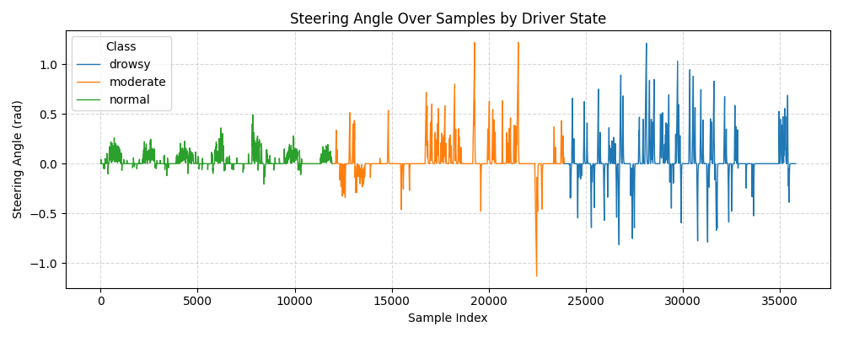

Fig.3 Data analysis on data capture(Steering_angle) by me on my laptop

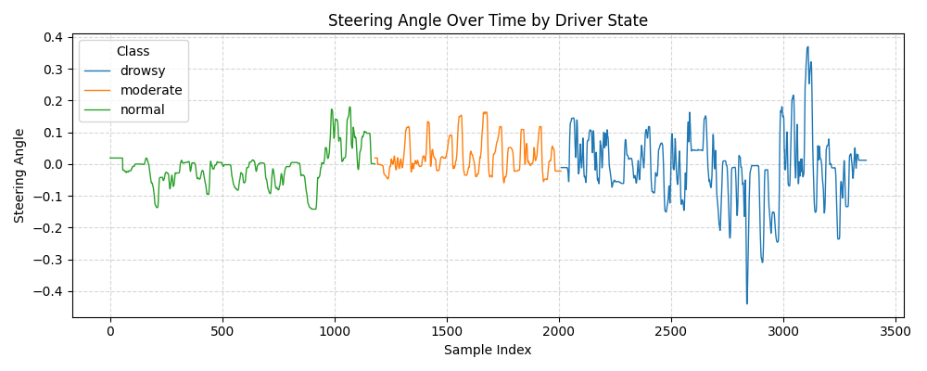

Fig.4 Data analysis on data capture(Steering_angle) by Mehdi

